**Group Meeting (6 Hours)**

**Sunday, March 18th, 2018**

**Physical Model Construction / Integration of Systems**

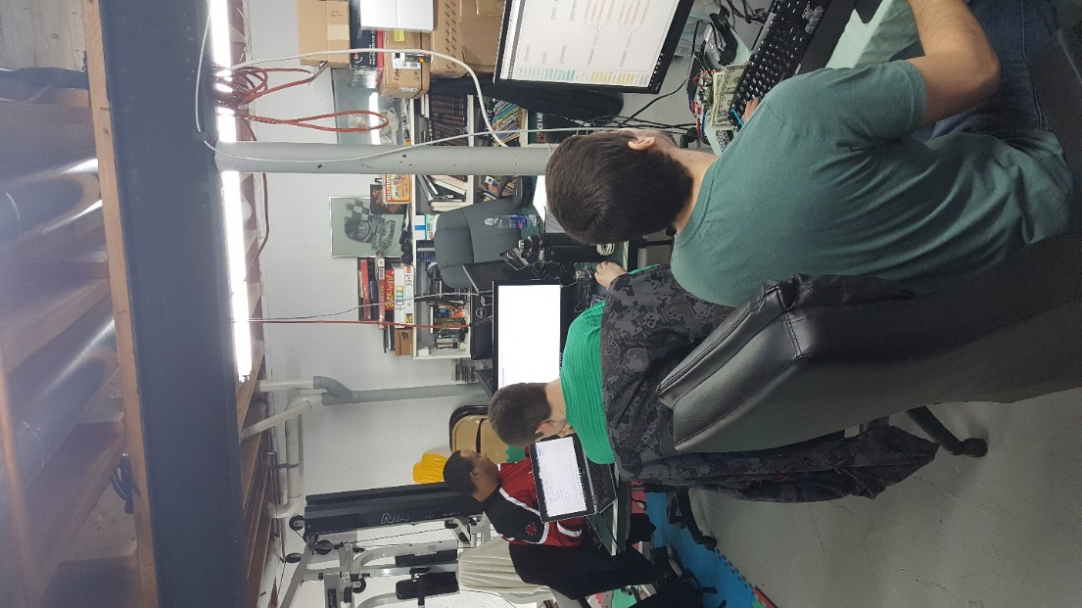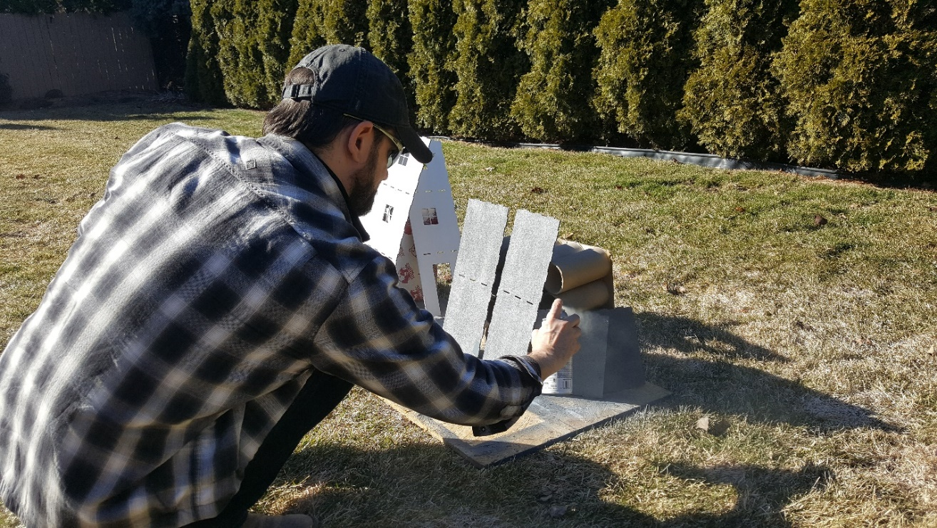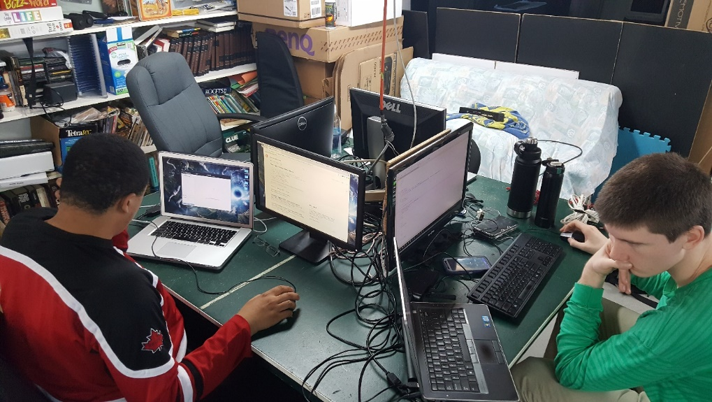

**Group Meeting (3 Hours)**

**Wednesday, March 21st, 2018**

**Physical Model Wiring**



